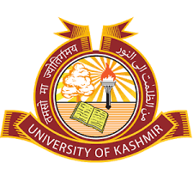
DIRECTORATE OF PHYSICAL EDUCATION & SPORTS
UNIVERSITY OF KASHMIR
(NAAC ACCREDITED GRADE “A”)
HAZRATBAL SRINAGAR, KASHMIR- 190006
Email:directorsportsku@uok.edu.in

NOTICE

It is for the information of all interested students / players of the University and affiliated Colleges that the Directorate is scheduled to conduct a Coaching Camp cum selection trails for Basketball (Men /Women) at Indoor Stadium, Srinagar w.e.f 09-10-2018 from 11:00 am onwards. All the interested students / players are directed to report on the venue on the scheduled date and time along with proper uniform and kit.

Sd/-
Coordinator Physical Education & Sports

No.F(Basketball-Coaching-camp–DPES)KU/18
Dated:- 06-10-18

Copy to the:-
- Nodal Principal, A.S College, Srinagar with the request to circulate among all the colleges of valley;
- Director IT & SS with the request to publish the notice on university web site.
- S.S to the Hon’ble Vice-Chancellor for kind information of the Hon’ble Vice-Chancellor;
- Assistant Directors for information and necessary action;
- P.S. to Registrar for kind information of the Registrar;
- PRO with the request to publish the notice in one local dailies;
- File.

